Grove - Thumb Joystick

|  |
| --- |
| **Contents**   [[hide](javascript:toggleToc())]   * [1 Introduction](http://www.seeedstudio.com/wiki/Grove_-_Thumb_Joystick#Introduction) * [2 Features](http://www.seeedstudio.com/wiki/Grove_-_Thumb_Joystick#Features) * [3 Application Ideas](http://www.seeedstudio.com/wiki/Grove_-_Thumb_Joystick#Application_Ideas) * [4 Specification](http://www.seeedstudio.com/wiki/Grove_-_Thumb_Joystick#Specification) * [5 Usage](http://www.seeedstudio.com/wiki/Grove_-_Thumb_Joystick#Usage) * [6 Resources](http://www.seeedstudio.com/wiki/Grove_-_Thumb_Joystick#Resources) * [7 Support](http://www.seeedstudio.com/wiki/Grove_-_Thumb_Joystick#Support) |

Introduction

Grove - Thumb Joystick is a Grove compatible module which is very similar to the 'analog' joystick on PS2 (PlayStation 2) controllers. Two direction movements will output different analog signals as they are actually two potentiometers. The resistor is ~10k for each.  
The joystick also has a push button that is could be used for special applications. When the module is in working mode it will output two analog values representing two directions. The value is restricted in a little smaller range (e.g 200~800)compared to the normal joystick, while it is around 1023 when the button is pushed, so that the MCU can detect the action of pressing.  
**Model:**[**COM90133P**](http://www.seeedstudio.com/depot/twig-thumb-joystick-p-935.html?cPath=156_160)

[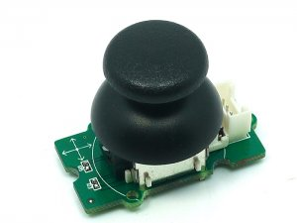](http://www.seeedstudio.com/wiki/File:Twig_-_Thumb_Joystick_v0.9b.jpg)

Features

* Grove Interface
* 5V/3.3V Compatible
* Analog Output

Application Ideas

* Game Controller

Specification

|  |  |  |  |  |
| --- | --- | --- | --- | --- |
| **Item** | **Min** | **Typical** | **Max** | **Unit** |
| **Work Voltage** | 4.75 | 5.0 | 5.25 | V |
| **Output Analog Value （X coordinate）** | 247 | 516 | 774 | \ |
| **Output Analog Value （Y coordinate）** | 241 | 507 | 783 | \ |

Usage

The Grove - Thumb Joystick is an analog device that outputs analog signal ranging from 0 - 1024. That requires we use the analog port of Arduino to take the readings.

1. Connect the module to the A0/A1 of [Grove - Basic Shield Grove - Basic Shield](http://www.seeedstudio.com/depot/grove-base-shield-p-754.html?cPath=132_134) using the 4-pin grove cable.  
2. Plug the Grove - Basic Shield into Arduino.  
3. Connect Arduino to PC by using a USB cable.  
(图片)  
4. Copy and paste code below to a new Arduino sketch. Please click here if you do not know how to upload.

/*

Thumb Joystick demo v1.0

by:http://www.seeedstudio.com

connec the module to A0&A1 for using;

*/

void setup() {

Serial.begin(9600);

}

void loop() {

int sensorValue1 = analogRead(A0);

int sensorValue2 = analogRead(A1);

Serial.print("The X and Y coordinate is:");

Serial.print(sensorValue1, DEC);

Serial.print(",");

Serial.println(sensorValue2, DEC);

Serial.println(" ");

delay(200);

}

5. You can check the value of the outputs analog signal after opening the Serial Monitor.

[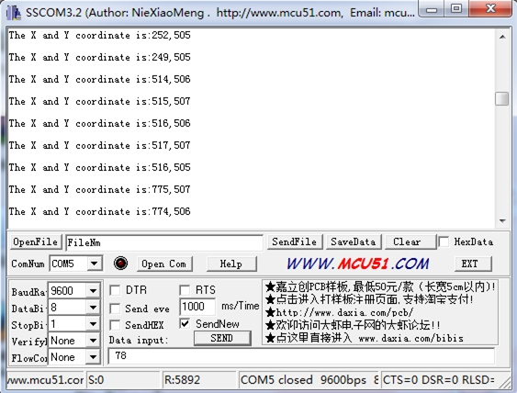](http://www.seeedstudio.com/wiki/File:Grove_-_Thumd_Joystick_Result.jpg)

The output value is reading from the analog port of Arduino which can convert to the corresponding resistance using the formula:R=(float)(1023-sensorValue)*10/sensorValue.

Resources

[Grove-Thumb Joystick Eagle File](http://www.seeedstudio.com/wiki/images/3/3d/Eagle_Design_Files.zip)